Advisor Guide
SPEAK FOR YOURSELF!
Understanding Shomei’a K’Oneh

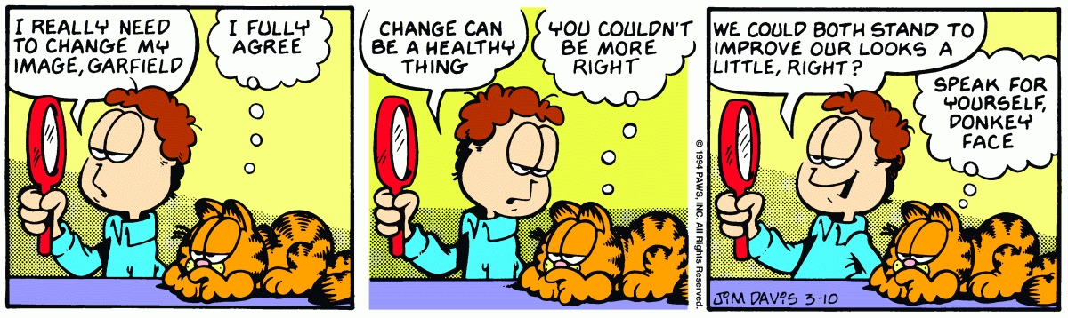
Before Opening the Packet-Introduce the concept of Shomei’a K’Oneh
1) What's an example of a bracha that you personally never say, but you say amen to? (Kiddush, Havdala, Megilla, HaMotzi, Bracha Acharona etc.)

2) What's an example of brachot that you personally say?

“Shomei’a K’oneh” allows you to listen to someone else’s Bracha or Mitzva (like saying Hallel in the first source) and get the Mitzva yourself. But that’s cheating! Why should that work?!
SCENARIO:
After a great night of singing at the Tisch, Friday night programming, and bonding on the walk home, your house wakes up a little late on Shabbat morning. Everyone rushes to get ready, but by the time you all get to shul it’s already 9:30. After stopping by the breakfast room to see if there’s any more donuts left out, you enter Shul while the rest of the people are praying the Shemoneh Esrei (silent prayer service, basically a one-on-one conversation with God).
You begin your Shmoneh Esrei and very quickly the Chazzan begins the public repetition. You realize that very soon he’ll be getting to Kedusha, that point when everyone joins together to praise God using three very important phrases:
קָדושׁ. קָדושׁ. קָדושׁ ה' צְבָאות. מְלא כָל הָאָרֶץ כְּבודו:
Holy, holy, holy is Hashem, Lord of awesome armies; the whole world is full of His glory.
בָּרוּךְ כְּבוד ה' מִמְּקומו:
Blessed is the Glory of God from His place.
יִמְלךְ ה' לְעולָם. אֱלהַיִךְ צִיּון לְדר וָדר. הַלְלוּיָהּ:
May Hashem reign forever - your God, O Zion - for each and every generation; praise Hashem
What should you do? Should you continue your own personal prayer, basically ignoring the public praise of God? Should you stop reciting your own personal Tefilla and recite the phrases along with the rest of the Shul, in which case you’ve interrupted your one-on-one audience with the King? Frozen by indecision, you wait as the Chazzan gets closer and closer to the Kedusha...
WHAT DO YOU DO???
The next page is a Gemara with a couple of sections marked off. Don’t read it inside-just point out the Gemara, Rashi, and Tosfos. There’s a bio for Rashi and Tosfos on the next page-explain very quickly what the Gemara is and let them know who Rashi and Tosfos are before learning their opinions.
The goal of the next section is to give the NCSYers an opportunity to get heavily involved in the learning.
Help them through the quote from the Gemara, Rashi and Tosfos. At that point, stop and let them take over-they should provide the thought process for both opinions, arguing it out if necessary.
Then, go one by one through the scenarios and apply the same two opinions to each scenario-you can make the NCSYers into ‘teams,’ appoint captains to argue each point, or challenge each person to apply the opposing opinions to each case and come out with the decision that should follow from each premise.
Rashi: As it’s not a Hefsek, but it still counts as if I participated in Kedusha, it must be tagging along with his speech and I somehow gives me credit (like the guy who does no work in a group project but still gets a good grade).
Tosfos (may be easier for them to figure out the logic): In order for it to be considered a Hefsek in my Shmoneh Esrei, it must be as if I’m SPEAKING by listening to Kedusha.
Be Ready to Explain Concepts such as: Hefsek, Chazzan, Shmoneh Esrei, Kedusha, Sfiras HaOmer, Birchat Kohanim
3-TOSFOT
2-RASHI
1-GEMARA
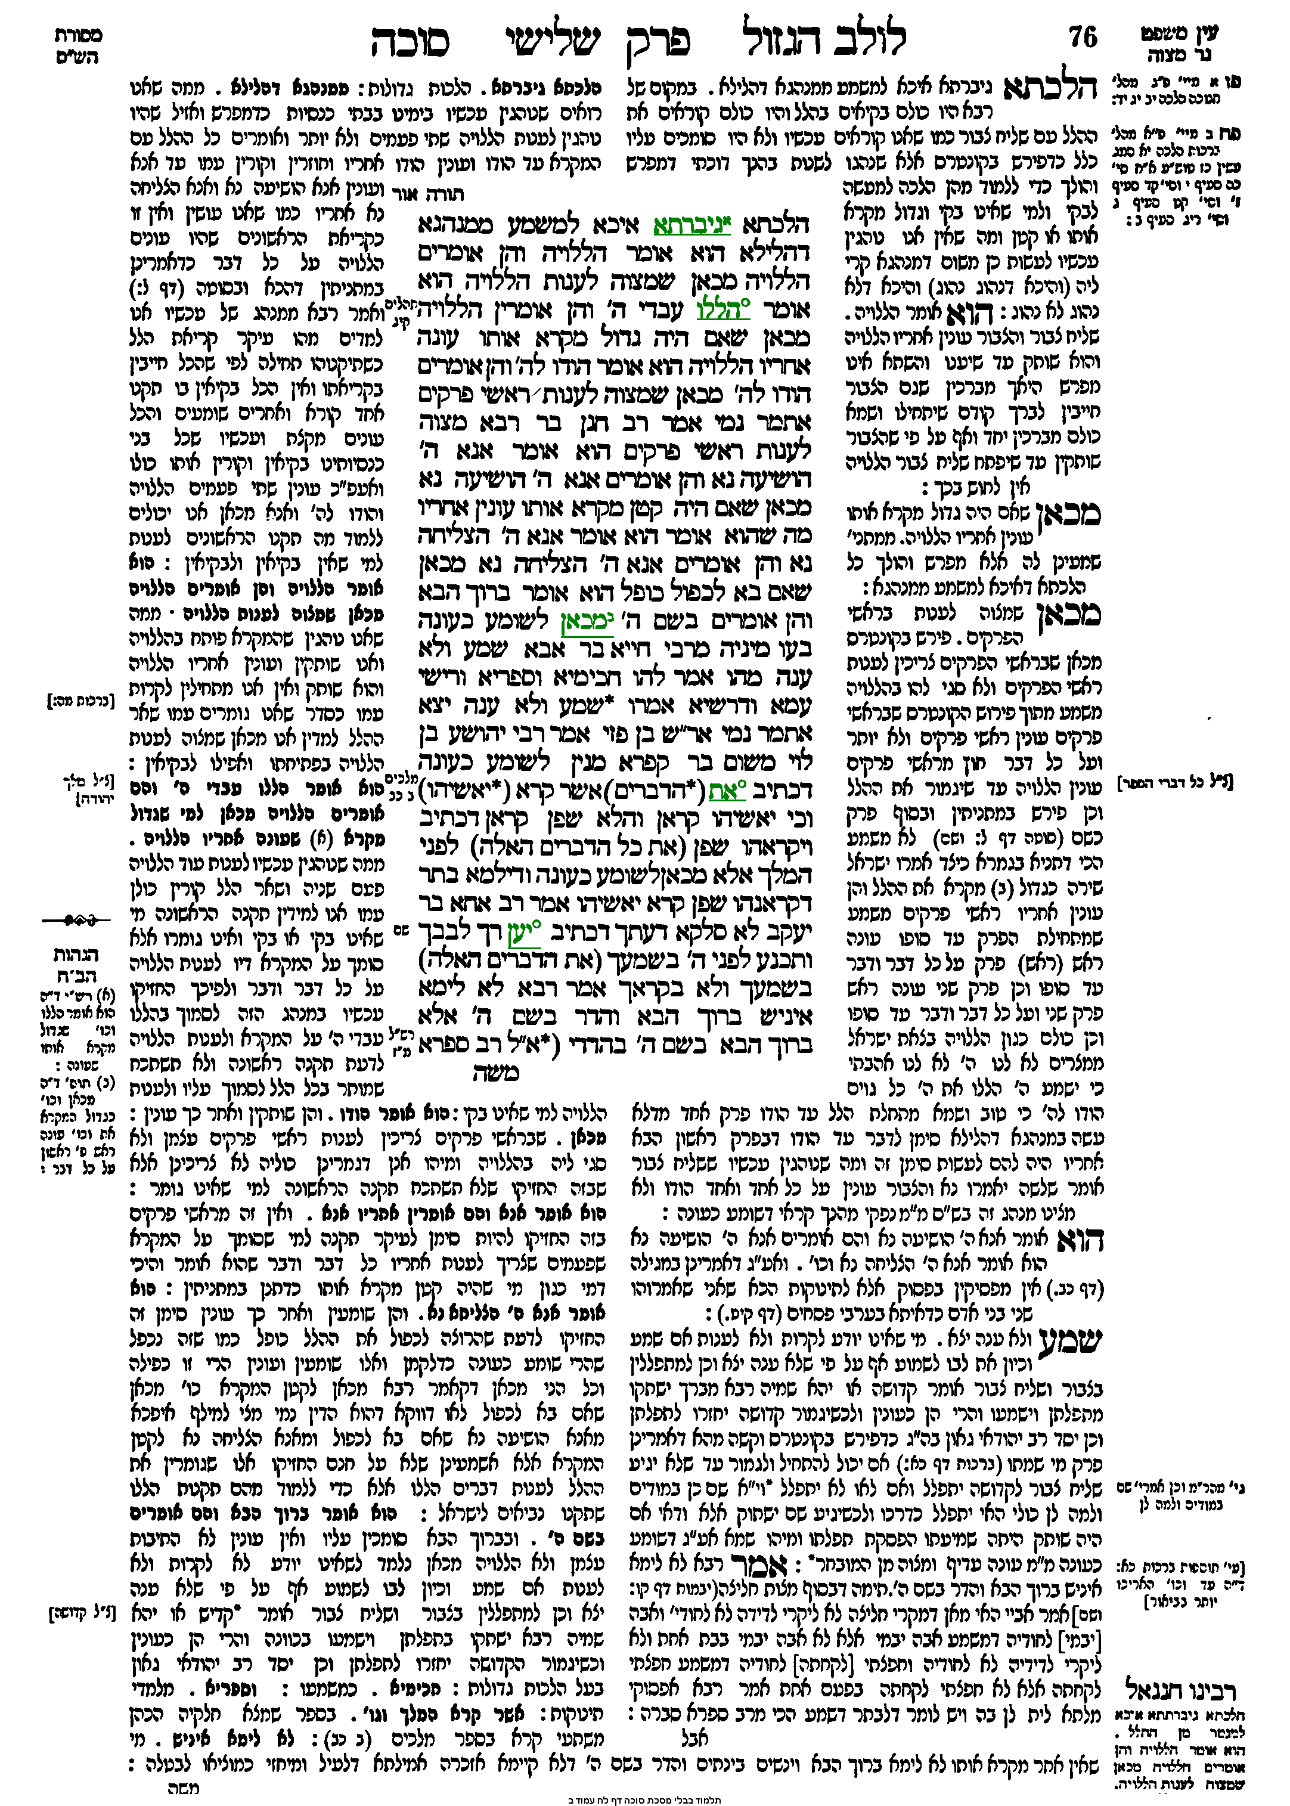

1-The Gemara
הוא אומר ברוך הבא והן אומרים בשם ה' מכאן לשומע כעונה
The Chazzan recites: “Blessed is one who comes” (Psalms 118:26), and the congregation recites the rest of the verse: “In the name of Hashem” (Psalms 118:26), in response. From here is the source of the halacha that the halachic status of one who hears a passage recited is equivalent to that of one who recites it, as the congregation fulfills its obligation even though the people not repeat the entire verse. This is called Shomei’a (he who hears) K’Oneh (is as if he responded).
בעו מיניה מרבי חייא בר אבא שמע ולא ענה מהו אמר להו חכימיא וספריא ורישי עמא ודרשיא אמרו שמע ולא ענה יצא
Based on this halacha, the Gemara relates that the Rabbis raised a dilemma to Rabbi Chiyya bar Abba: If a person heard a passage recited and did not recite it himself, did he fulfill his obligation or not? Rabbi Chiyya bar Abba said to them that the Sages, and the schoolteachers, and the heads of the nation, and the speech-givers said: One who heard a passage recited and did not recite it himself fulfilled his obligation.

2-Rashi’s Opinion: (Rabbi Shlomo Yitzchaki, 1040-1105. Wrote commentaries on the written Torah (24 books of Tanach) and the Gemara, making these basic works accessible to the average everyday Jew)
וכן למתפללין בצבור ושליח צבור אומר קדושה או יהא שמיה רבא ישתקו בתפלתן וישמעו בכוונה והרי הן כעונין וכשיגמור הקדושה יחזרו לתפלתן וכן יסד רב יהודאי גאון בעל הלכות גדולות:
… And similarly, when praying with a Minyan and the Chazzan is saying Kedusha or Y’hei Shmei Rabba…(May Hashem’s great reputation spread...), you should be quiet (pause your own prayer) and pay attention to the Chazzan. This way, you’ll get credit as if you answered. When Kedusha is finished, you can return to your own prayer. This is the opinion of Rabbi Yehudai Gaon.

3-Tosfot’s Opinion: (A school dedicated to understanding the Talmud in a broad sense. Influential members of this school include Rashi’s grandchildren and sons-in-law)
אם היה שותק היתה שמיעתו הפסקת תפלתו
In the case that Rashi is discussing, the person in the middle of davening who tries to use Shomei’a K’Oneh (listening to the Chazzan to count as if he responded himself) will have interrupted his Shmoneh Esrei!

Applications:
- I’m listening to a friend make HaMotzi, and I realize that he spoke after finishing the Bracha but before taking the bite-he needs to make a new Bracha! But do I?
Pri Megadim-As if I said the Bracha myself-no new Bracha (Beis HaLevi). Biur Halacha-Use his Bracha-in this case, he lost his Bracha, so I lost mine as well (Chazon Ish).
- I’m listening to a friend make HaMotzi, and after he finishes his Bracha I turn to the person next to me and make a random comment about how cold it is in the room. Do I need to make a new Bracha?
Rema-NO! Presumably, assumes I’m using his Bracha-Chazon Ish. All the Acharonim-YES! Presumably, looked at as if I said the Bracha myself-I was Mafsik, so I need a new Bracha.
- Do I need to stand while listening to the Shliach Tzibbur for Shmoneh Esrei? Especially if I’m planning on using his Shmoneh Esrei…Also, do I take my own 3 steps back and forth when starting and ending?
Rema says you should stand-presumably, he’s assuming that it’s like I’m saying the words myself (Beis HaLevi)! Beis Yosef has 2 opinions regarding taking 3 steps-presumably, if you say yes you hold that it’s like you’re saying the words yourself (Beis HaLevi)-Rema says yes! If you say no, you’re assuming that you’re using the Chazzan’s Bracha/Brachot-no need to stand and no need to take my own steps (Chazon Ish).
- My friend is a Kohen who has never blessed the people on Yom Tov before, and he’s nervous about doing it for the first time. Can he go up on the Bima with the other Kohanim and just listen to them do it? (Background info: One of the Halachot is that the blessing must be made B’Kol Ram, in a loud voice).

This is the original case in which the Beis HaLevi and Chazon Ish suggest their Shitos. The Beis HaLevi thinks that you listening to another makes it like you said the words he said. While that’s very nice, it won’t give you the feature of B’Kol Ram needed for Birchas Kohanim. The Chazon Ish thinks that Shomei’a K’Oneh works through me latching on to your Mitzva. Since you said it B’Kol Ram and did it correctly, me listening gives me ‘credit’ for your Mitzva. (The same Chiluk works for the Neshima Achas of saying the 10 sons of Haman).

- There is a Halacha that Sefiras HaOmer must be done by every individual (rather than the Beit Din counting for everyone, like what was done by Shemitta). Can you use Shomeia L’Oneh, or is that considered having someone else count for me?
If you look at Shomei’a K’Oneh as using someone else’s Bracha, not ok (Chazon Ish). If you look at it as if I’m saying the words that I’m hearing, it’d be like I counted myself (Beis HaLevi).
- Can I listen to a friend make the “Baruch Ata HaShem” part of a bracha that he needs to make, and then I fill in the ending for a different Bracha that I need to make? For example, use the first half of someone’s Bracha on reading the Torah for my Kiddush on Shabbat morning.

R’ Akiva Eiger, quoted in Kehillas Yaakov Brachos 11

Why Do We Talk?
Megillat Kohelet, Chapter 3
לַכֹּ֖ל זְמָ֑ן וְעֵ֥ת לְכָל־חֵ֖פֶץ תַּ֥חַת הַשָּׁמָֽיִם...
A season is set for everything, a time for every experience under heaven…
עֵ֤ת לְבַקֵּשׁ֙ וְעֵ֣ת לְאַבֵּ֔ד עֵ֥ת לִשְׁמ֖וֹר וְעֵ֥ת לְהַשְׁלִֽיךְ׃
A time for seeking and a time for losing, A time for keeping and a time for discarding;
עֵ֤ת לִקְר֙וֹעַ֙ וְעֵ֣ת לִתְפּ֔וֹר עֵ֥ת לַחֲשׁ֖וֹת וְעֵ֥ת לְדַבֵּֽר׃
A time for ripping and a time for sewing, A time for silence and a time to speak;
Discuss-When’s the right time to talk-what are different goals of using speech?

2 examples of how we shouldn’t use our speech:

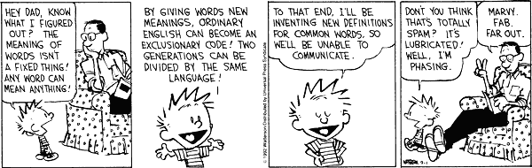
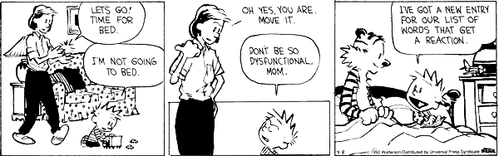

Wrap-Up
Shomei’a K’Oneh highlights something unique about speech-speech is a powerful tool that can be used to connect with other people, motivate them to go out and do something, explain a new concept, and many other things. The two perspectives on Shomei’a K’Oneh discussed in this session highlight two ways of looking at how speech works:
According to Rashi, me listening to someone else allows me to use his Bracha. In other words, his speech drew me in and made me a part of who he is and the Mitzva that he’s doing. For example, if you wanted your parents to give you a higher allowance, you can either just ask for more money, or you can explain the following: You’re trying to become more independent and more responsible. You feel it would help you if your parents trusted you with a little extra money each week to manage to give you an opportunity to practice your newfound maturity. Explaining your thought process and ‘bringing your parents in’ is a much more likely strategy to succeed (see Simon Sinek’s TED talk: How Great Leaders Inspire Action).
According to Tosfos, me listening to someone else actually makes it like I spoke myself. His action, his speech, inspired me to do as he did. Another model of how speech connects us is through the sharing of ideas and calling others to action. When you view certain types of interactions as more than just sharing ideas, but rather set the goal as getting them to act on something you’re passionate about, your whole delivery changes. Instead of presenting an idea, you need to make sure they know what steps to take and what you’ve done yourself to inspire them to take action like you have.
We started with what seemed like a strange, almost random Halachic concept: I can ‘cheat the system’ and get out of making a Bracha by listening to someone else say it. When we looked a little deeper, we were able to understand on our own what the logic behind the concept could be, with a little help from Rashi and Tosfos. The concept was no longer random, no longer trying to cheat the system. Now, we’ve taken it one step more-this Halachic concept actually informs our goals when using speech to connect with others, every time we talk to our friends, haggle for points with a teacher, or give a presentation at the next school assembly or club meeting.

