SPEAK FOR YOURSELF!
Understanding Shomei’a K’Oneh

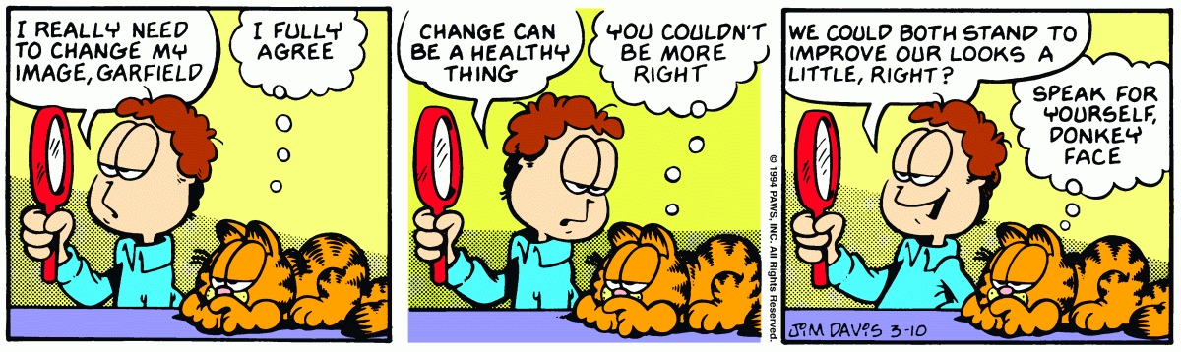

SCENARIO:
After a great night of singing at the Tisch, Friday night programming, and bonding on the walk home, your house wakes up a little late on Shabbat morning. Everyone rushes to get ready, but by the time you all get to shul it’s already 9:30. After stopping by the breakfast room to see if there’s any more donuts left out, you enter Shul while the rest of the people are praying the Shemoneh Esrei (silent prayer service, basically a one-on-one conversation with God).
You begin your Shmoneh Esrei and very quickly the Chazzan begins the public repetition. You realize that very soon he’ll be getting to Kedusha, that point when everyone joins together to praise God using three very important phrases:
קָדושׁ. קָדושׁ. קָדושׁ ה' צְבָאות. מְלא כָל הָאָרֶץ כְּבודו:
Holy, holy, holy is Hashem, Lord of awesome armies; the whole world is full of His glory.
בָּרוּךְ כְּבוד ה' מִמְּקומו:
Blessed is the Glory of God from His place.
יִמְלךְ ה' לְעולָם. אֱלהַיִךְ צִיּון לְדר וָדר. הַלְלוּיָהּ:
May Hashem reign forever - your God, O Zion - for each and every generation; praise Hashem
What should you do? Should you continue your own personal prayer, basically ignoring the public praise of God? Should you stop reciting your own personal Tefilla and recite the phrases along with the rest of the Shul, in which case you’ve interrupted your one-on-one audience with the King? Frozen by indecision, you wait as the Chazzan gets closer and closer to the Kedusha...
WHAT DO YOU DO???
3-TOSFOT
2-RASHI
1-GEMARA
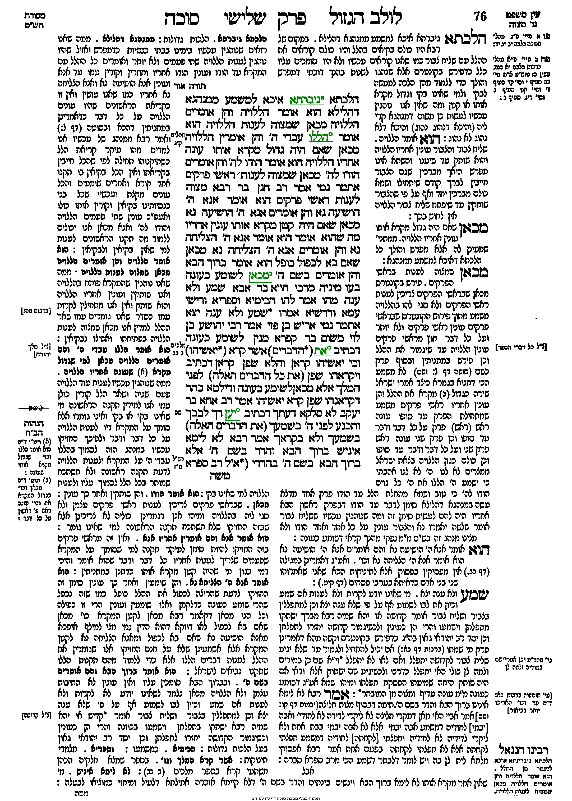

1-The Gemara
הוא אומר ברוך הבא והן אומרים בשם ה' מכאן לשומע כעונה
The Chazzan recites: “Blessed is one who comes” (Psalms 118:26), and the congregation recites the rest of the verse: “In the name of Hashem” (Psalms 118:26), in response. From here is the source of the halacha that the halachic status of one who hears a passage recited is equivalent to that of one who recites it, as the congregation fulfills its obligation even though the people not repeat the entire verse. This is called Shomei’a (he who hears) K’Oneh (is as if he responded).
בעו מיניה מרבי חייא בר אבא שמע ולא ענה מהו אמר להו חכימיא וספריא ורישי עמא ודרשיא אמרו שמע ולא ענה יצא
Based on this halacha, the Gemara relates that the Rabbis raised a dilemma to Rabbi Chiyya bar Abba: If a person heard a passage recited and did not recite it himself, did he fulfill his obligation or not? Rabbi Chiyya bar Abba said to them that the Sages, and the schoolteachers, and the heads of the nation, and the speech-givers said: One who heard a passage recited and did not recite it himself fulfilled his obligation.

2-Rashi’s Opinion: (Rabbi Shlomo Yitzchaki, 1040-1105. Wrote commentaries on the written Torah (24 books of Tanach) and the Gemara, making these basic works accessible to the average everyday Jew)
וכן למתפללין בצבור ושליח צבור אומר קדושה או יהא שמיה רבא ישתקו בתפלתן וישמעו בכוונה והרי הן כעונין וכשיגמור הקדושה יחזרו לתפלתן וכן יסד רב יהודאי גאון בעל הלכות גדולות:
… And similarly, when praying with a Minyan and the Chazzan is saying Kedusha or Y’hei Shmei Rabba…(May Hashem’s great reputation spread...), you should be quiet (pause your own prayer) and pay attention to the Chazzan. This way, you’ll get credit as if you answered. When Kedusha is finished, you can return to your own prayer. This is the opinion of Rabbi Yehudai Gaon.

3-Tosfot’s Opinion: (A school dedicated to understanding the Talmud in a broad sense. Influential members of this school include Rashi’s grandchildren and sons-in-law)
אם היה שותק היתה שמיעתו הפסקת תפלתו
In the case that Rashi is discussing, the person in the middle of davening who tries to use Shomei’a K’Oneh (listening to the Chazzan to count as if he responded himself) will have interrupted his Shmoneh Esrei!

Applications:
- I’m listening to a friend make Hamotzi on Shabbat, and I realize that he spoke after finishing the Bracha but before taking the bite - he needs to make a new Bracha on his bread! But do I?

- I’m listening to a friend make HaMotzi on Shabbat, and after he finishes his Bracha I turn to the person next to me and make a random comment about how cold it is in the room. Do I need to make a new Bracha on my bread?

- Do I need to stand while listening to the Chazzan for Shmoneh Esrei? Especially if I’m planning on using his Shmoneh Esrei…Also, do I take my own 3 steps back and forth when starting and ending?

- My friend is a Kohen who has never blessed the people on Yom Tov before, and he’s nervous about doing it for the first time. Can he go up on the Bima (platform in front of the Shul) with the other Kohanim and just listen to them do it? (Background info: One of the Halachot is that the blessing must be made B’Kol Ram, in a loud voice).

- There is a Halacha that Sefirat HaOmer (counting between Pesach and Shavuot) must be done by every individual (rather than the Beit Din-Jewish court-counting for everyone, like what was done by Shemitta). Can you use Shomeia K’Oneh, or is that considered having someone else count for me?

- Can I listen to a friend make the “Baruch Ata HaShem” part of a Bracha that he needs to make, and then I fill in the ending for a different Bracha that I need to make? For example, use the first half of someone’s Bracha on reading the Torah for my Kiddush on Shabbat morning.

Why Do We Talk?
Megillat Kohelet, Chapter 3
לַכֹּ֖ל זְמָ֑ן וְעֵ֥ת לְכָל־חֵ֖פֶץ תַּ֥חַת הַשָּׁמָֽיִם...
A season is set for everything, a time for every experience under heaven…
עֵ֤ת לְבַקֵּשׁ֙ וְעֵ֣ת לְאַבֵּ֔ד עֵ֥ת לִשְׁמ֖וֹר וְעֵ֥ת לְהַשְׁלִֽיךְ׃
A time for seeking and a time for losing, A time for keeping and a time for discarding;
עֵ֤ת לִקְר֙וֹעַ֙ וְעֵ֣ת לִתְפּ֔וֹר עֵ֥ת לַחֲשׁ֖וֹת וְעֵ֥ת לְדַבֵּֽר׃
A time for ripping and a time for sewing, A time for silence and a time to speak;
